Right Circular Conical Surface
# Source: AI Source: Provided by: [Data Path: Persons Table -> ID Column: 1, Name_En Column: Motasem Essam] -> From: [ChatGPT] on [7/20/2026]
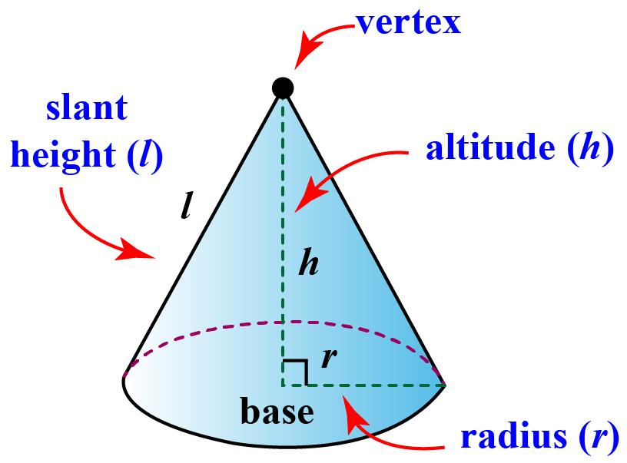
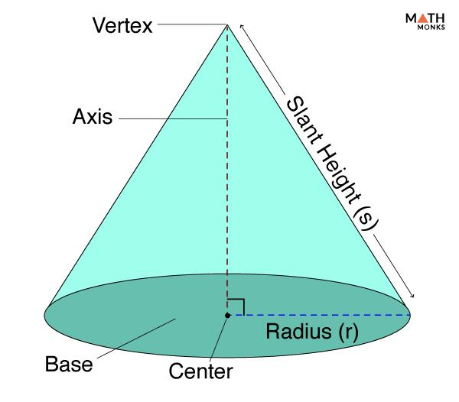
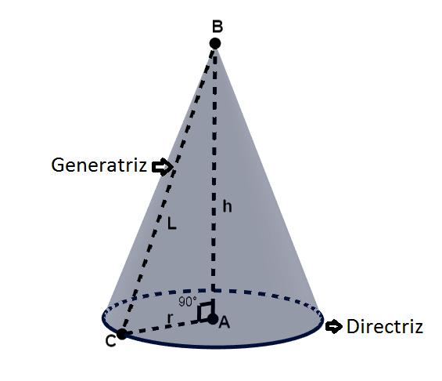
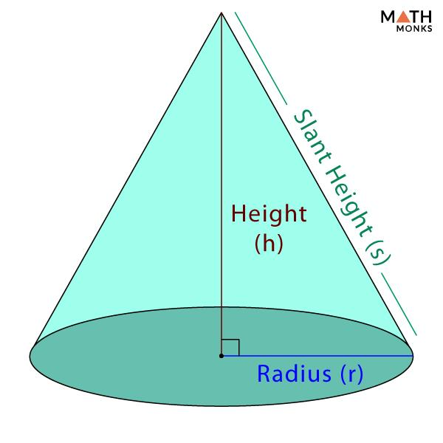
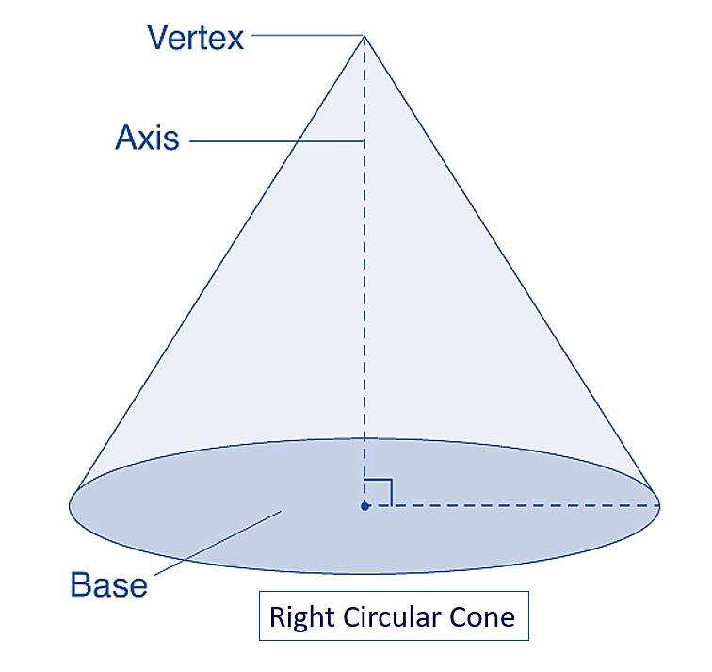
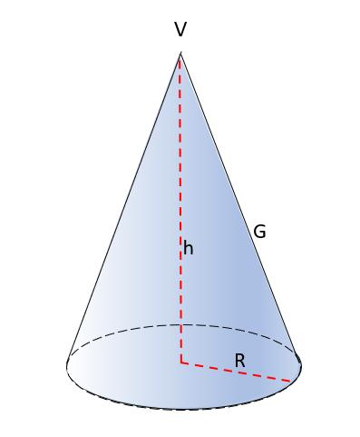

Definition
# Source: AI Source: Provided by: [Data Path: Persons Table -> ID Column: 1, Name_En Column: Motasem Essam] -> From: [ChatGPT] on [7/20/2026]
A Right Circular Conical Surface is a conical surface generated by a straight line, called a generator, that passes through a fixed point called the vertex and moves around a circular directrix, with the axis perpendicular to the plane of the circular directrix.
In a right circular conical surface:
- The directrix is a circle.
- All generators pass through the same vertex.
- The axis passes through the center of the circle.
- The axis is perpendicular to the base plane.
- The vertex lies directly above or below the center of the circular base.
It is the curved lateral surface of a right circular cone, without the circular base.

Purpose
# Source: AI Source: Provided by: [Data Path: Persons Table -> ID Column: 1, Name_En Column: Motasem Essam] -> From: [ChatGPT] on [7/20/2026]
A right circular conical surface is used to:
- Describe the lateral surface of a right circular cone.
- Study relationships between radius, height, and slant height.
- Calculate curved surface area.
- Model conical structures.
- Provide a fundamental surface in solid geometry.
- Support applications in engineering, architecture, optics, and manufacturing.

Fundamental Elements
# Source: AI Source: Provided by: [Data Path: Persons Table -> ID Column: 1, Name_En Column: Motasem Essam] -> From: [ChatGPT] on [7/20/2026]
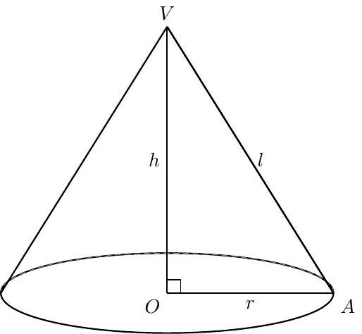
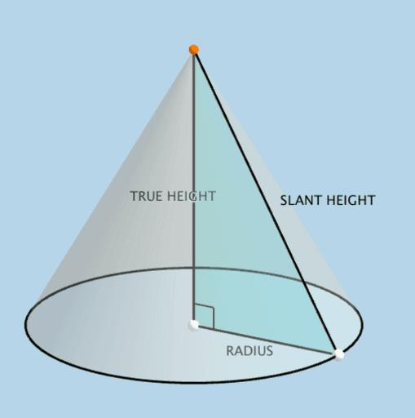
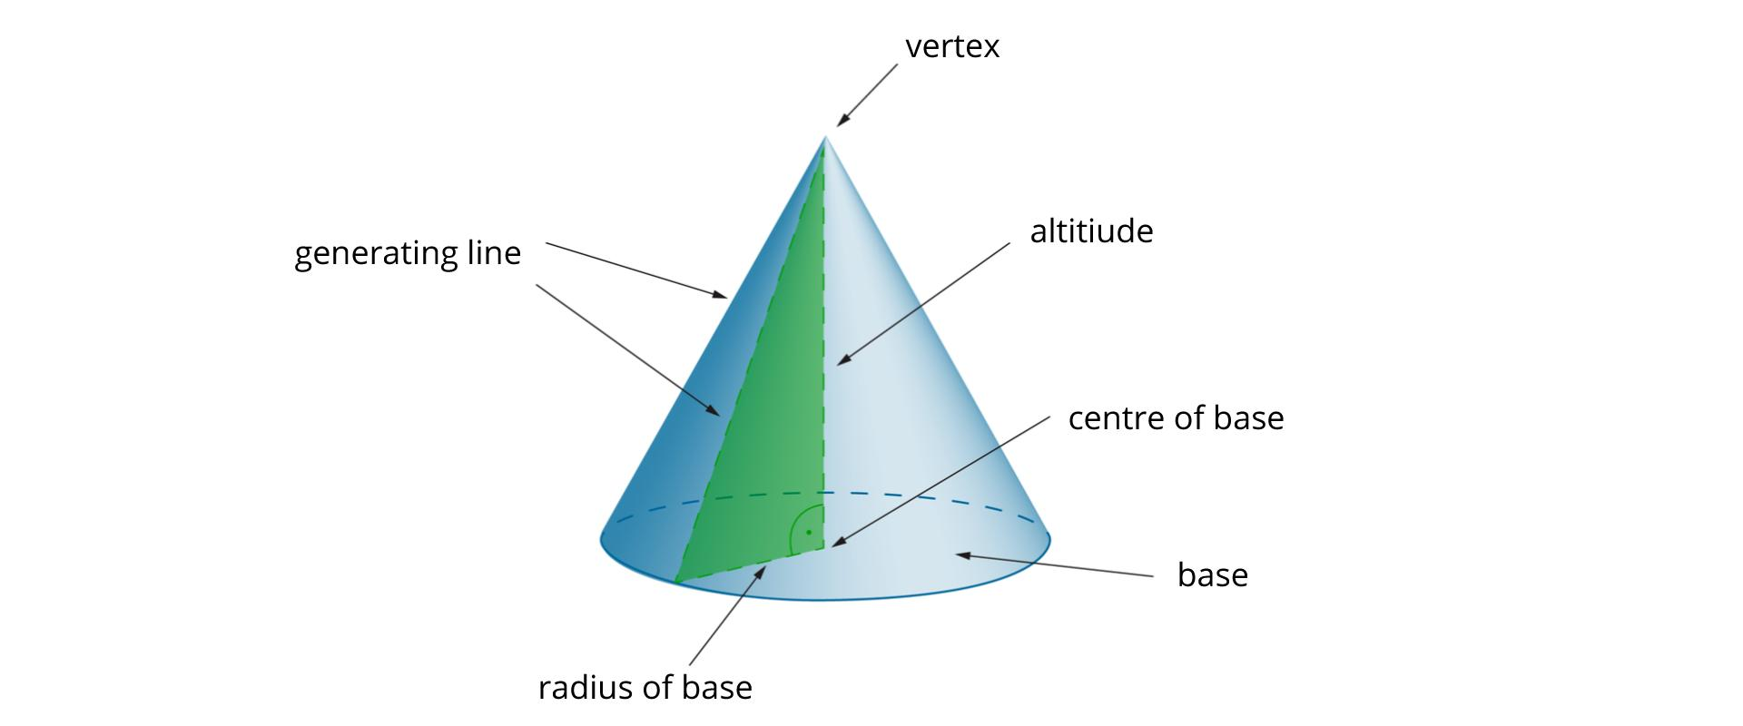
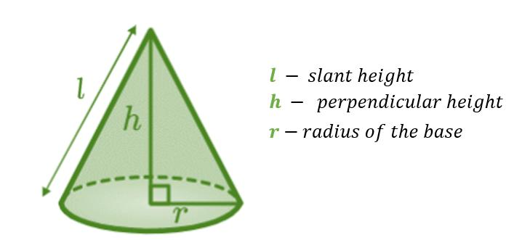

1. Vertex
# Source: AI Source: Provided by: [Data Path: Persons Table -> ID Column: 1, Name_En Column: Motasem Essam] -> From: [ChatGPT] on [7/20/2026]
The vertex $V$is the fixed point through which all generators pass.

2. Circular Directrix
# Source: AI Source: Provided by: [Data Path: Persons Table -> ID Column: 1, Name_En Column: Motasem Essam] -> From: [ChatGPT] on [7/20/2026]
The directrix is the circular curve forming the base boundary.
Its radius is denoted by
$$r.$$

3. Axis
# Source: AI Source: Provided by: [Data Path: Persons Table -> ID Column: 1, Name_En Column: Motasem Essam] -> From: [ChatGPT] on [7/20/2026]
The axis is the line joining the vertex to the center $O$of the circular directrix.
For a right circular conical surface,
$$VO⊥\text{base plane}.$$

4. Height
# Source: AI Source: Provided by: [Data Path: Persons Table -> ID Column: 1, Name_En Column: Motasem Essam] -> From: [ChatGPT] on [7/20/2026]
The height $h$is the perpendicular distance from the vertex to the plane of the circular directrix.
$$\boxed{h=VO}$$

5. Generator
# Source: AI Source: Provided by: [Data Path: Persons Table -> ID Column: 1, Name_En Column: Motasem Essam] -> From: [ChatGPT] on [7/20/2026]
A generator is a straight line segment joining the vertex to a point on the circular directrix.

6. Slant Height
# Source: AI Source: Provided by: [Data Path: Persons Table -> ID Column: 1, Name_En Column: Motasem Essam] -> From: [ChatGPT] on [7/20/2026]
For a right circular cone, the slant height $l$is the length of a generator from the vertex to the circular boundary.

Mathematical Representation
# Source: AI Source: Provided by: [Data Path: Persons Table -> ID Column: 1, Name_En Column: Motasem Essam] -> From: [ChatGPT] on [7/20/2026]
Consider a right circular conical surface with:
- Vertex at $V=\left(0 , 0 , h\right)$
- Circular directrix in the plane $z=0$
- Center $O=\left(0 , 0 , 0\right)$
- Radius $r$
The circular directrix is
$$x^{2}+y^{2}=r^{2}, z=0.$$
The conical surface can be represented by
$$\boxed{x^{2}+y^{2}=\frac{r^{2}}{h^{2}}{\left(h-z\right)}^{2}}$$
for
$$0≤z≤h.$$
This describes the finite lateral surface between the vertex and the circular directrix.
An equivalent form is
$$\boxed{h^{2}\left(x^{2}+y^{2}\right)=r^{2}{\left(h-z\right)}^{2}}.$$

Parametric Representation
# Source: AI Source: Provided by: [Data Path: Persons Table -> ID Column: 1, Name_En Column: Motasem Essam] -> From: [ChatGPT] on [7/20/2026]
A convenient parametric representation is
$$\boxed{x=\frac{r}{h}\left(h-t\right)\cos{θ}} \\ \boxed{y=\frac{r}{h}\left(h-t\right)\sin{θ}} \\ \boxed{z=t}$$
where
$$0≤θ<2π$$
and
$$0≤t≤h.$$
At $t=h$, the surface reaches the vertex.
At $t=0$, the surface reaches the circular directrix.

Relationship Between Radius, Height, and Slant Height
# Source: AI Source: Provided by: [Data Path: Persons Table -> ID Column: 1, Name_En Column: Motasem Essam] -> From: [ChatGPT] on [7/20/2026]
A cross-section through the axis of a right circular cone produces an isosceles triangle.
Each half of this triangle is a right triangle.
Therefore, by the Pythagorean theorem,
$$\boxed{l^{2}=r^{2}+h^{2}}$$
and consequently,
$$\boxed{l=\sqrt{r^{2}+h^{2}}}.$$
This is one of the most important relationships for a right circular conical surface.
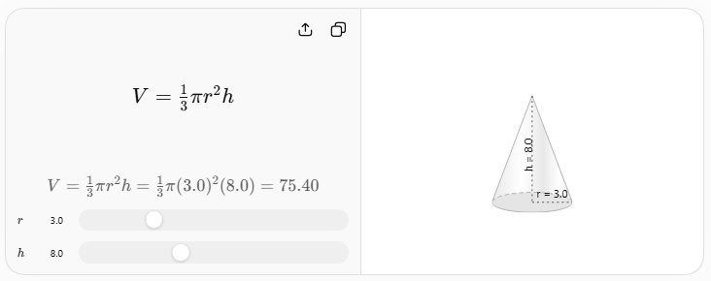

Curved Surface Area
# Source: AI Source: Provided by: [Data Path: Persons Table -> ID Column: 1, Name_En Column: Motasem Essam] -> From: [ChatGPT] on [7/20/2026]
The curved surface area of a right circular conical surface is
$$\boxed{A=πrl}$$
where:
- $r$= base radius
- $l$= slant height
Since
$$l=\sqrt{r^{2}+h^{2}},$$
the formula can also be written as
$$\boxed{A=πr\sqrt{r^{2}+h^{2}}}.$$
This formula refers to the lateral curved surface only, not the circular base.

Total Surface Area
# Source: AI Source: Provided by: [Data Path: Persons Table -> ID Column: 1, Name_En Column: Motasem Essam] -> From: [ChatGPT] on [7/20/2026]
If the circular base is included, the resulting closed surface has total surface area
$$\boxed{A_{\text{total}}=πrl+πr^{2}}.$$
Factoring:
$$\boxed{A_{\text{total}}=πr\left(l+r\right)}.$$
However, the right circular conical surface itself normally refers to the curved surface, so
$$\boxed{A_{\text{curved}}=πrl}.$$

Development of the Surface
# Source: AI Source: Provided by: [Data Path: Persons Table -> ID Column: 1, Name_En Column: Motasem Essam] -> From: [ChatGPT] on [7/20/2026]
The curved surface of a right circular cone can be unfolded into a sector of a circle.
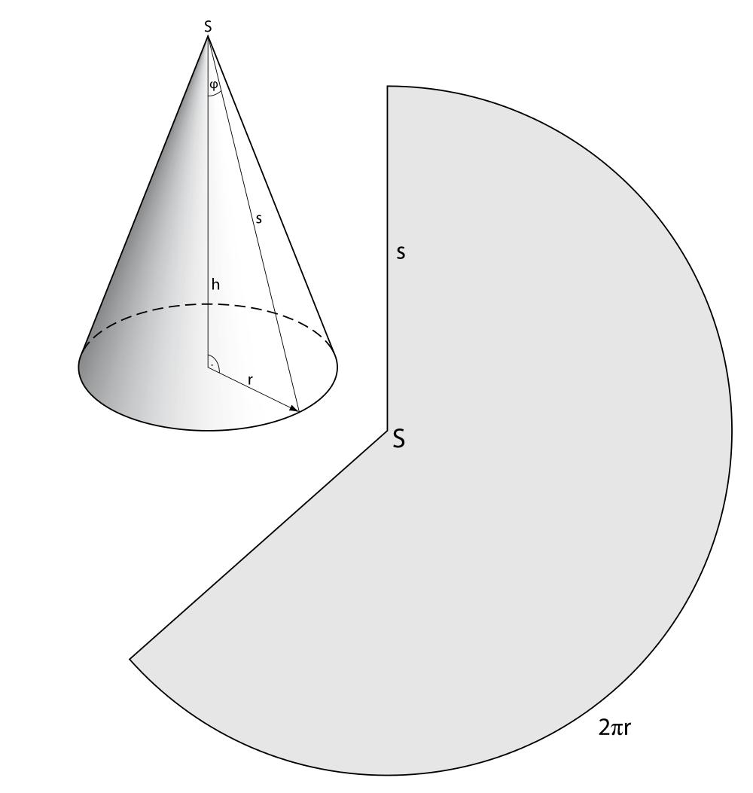
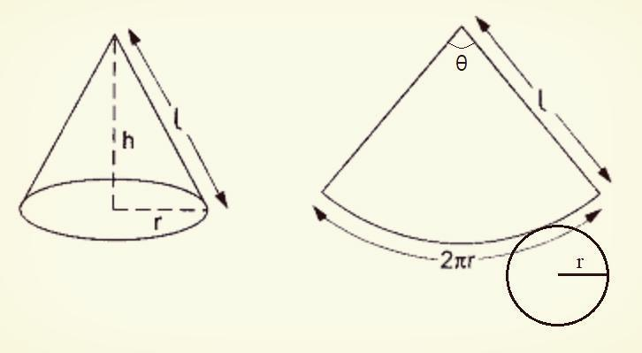
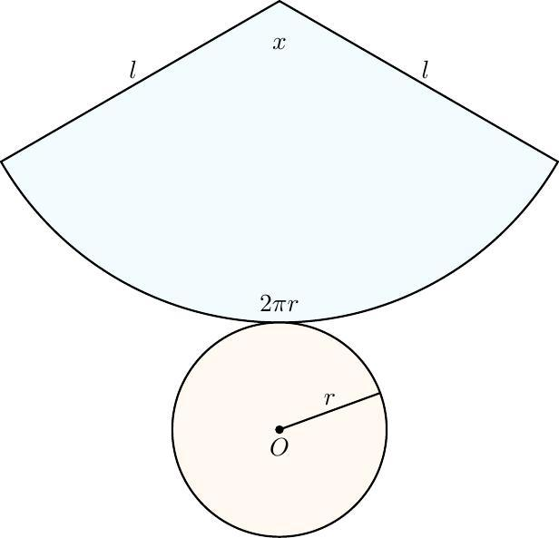
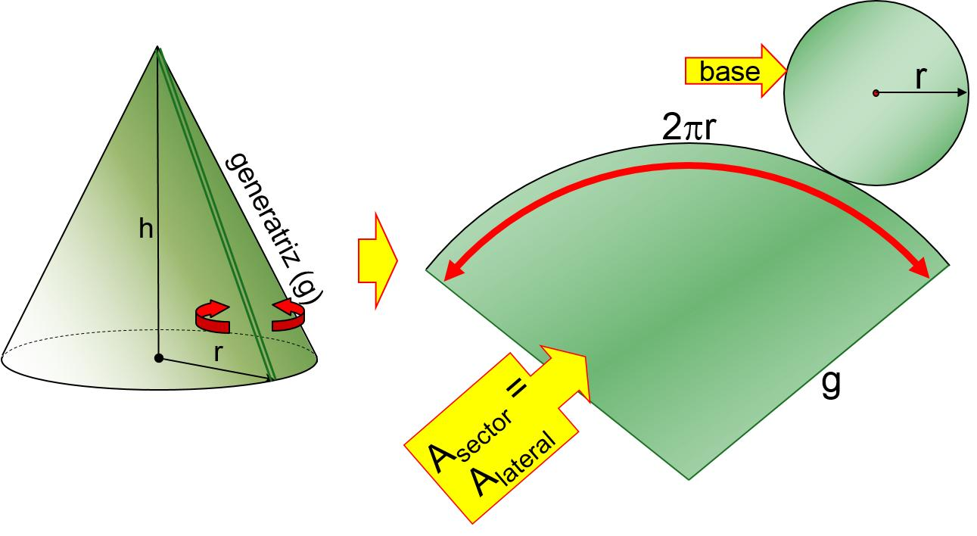
The sector has:
- Radius $l$
- Arc length $2πr$
The sector's arc corresponds to the circumference of the circular directrix.
Therefore,
$$lθ=2πr$$
when $θ$is measured in radians.
Thus,
$$\boxed{θ=\frac{2πr}{l}}.$$

Example 1 – Finding Slant Height
# Source: AI Source: Provided by: [Data Path: Persons Table -> ID Column: 1, Name_En Column: Motasem Essam] -> From: [ChatGPT] on [7/20/2026]
Suppose
$$r=3\text{ cm}$$
and
$$h=4\text{ cm}.$$
Using
$$l=\sqrt{r^{2}+h^{2}},$$
we obtain
$$l=\sqrt{3^{2}+4^{2}} \\ l=\sqrt{9+16} \\ l=\sqrt{25} \\ \boxed{l=5\text{ cm}}.$$

Example 2 – Finding Curved Surface Area
# Source: AI Source: Provided by: [Data Path: Persons Table -> ID Column: 1, Name_En Column: Motasem Essam] -> From: [ChatGPT] on [7/20/2026]
Suppose
$$r=3\text{ cm}$$
and
$$l=5\text{ cm}.$$
Then
$$A=πrl \\ A=π\left(3\right)\left(5\right) \\ \boxed{A=15π{\text{ cm}}^{2}}.$$
Approximately,
$$\boxed{A≈47.12{\text{ cm}}^{2}}.$$

Example 3 – Finding Height
# Source: AI Source: Provided by: [Data Path: Persons Table -> ID Column: 1, Name_En Column: Motasem Essam] -> From: [ChatGPT] on [7/20/2026]
Suppose
$$r=6\text{ cm}$$
and
$$l=10\text{ cm}.$$
From
$$l^{2}=r^{2}+h^{2},$$
we have
$$h^{2}=l^{2}-r^{2} \\ h^{2}={10}^{2}-6^{2} \\ h^{2}=100-36 \\ h^{2}=64.$$
Therefore,
$$\boxed{h=8\text{ cm}}.$$

Main Properties
# Source: AI Source: Provided by: [Data Path: Persons Table -> ID Column: 1, Name_En Column: Motasem Essam] -> From: [ChatGPT] on [7/20/2026]
A right circular conical surface has the following properties:
- Its directrix is a circle.
- All generators pass through one common vertex.
- The axis passes through the center of the directrix.
- The axis is perpendicular to the base plane.
- All generators have the same length when measured from the vertex to the circular directrix.
- The surface has one vertex.
- The lateral surface is curved.
- The finite lateral surface has one circular boundary curve.
- The lateral surface alone is an open surface.
- Adding the circular base produces a closed surface.
- The surface has rotational symmetry about its axis.
- A plane through the axis produces an isosceles triangular cross-section.

Right Circular vs Oblique Circular Conical Surface
# Source: AI Source: Provided by: [Data Path: Persons Table -> ID Column: 1, Name_En Column: Motasem Essam] -> From: [ChatGPT] on [7/20/2026]
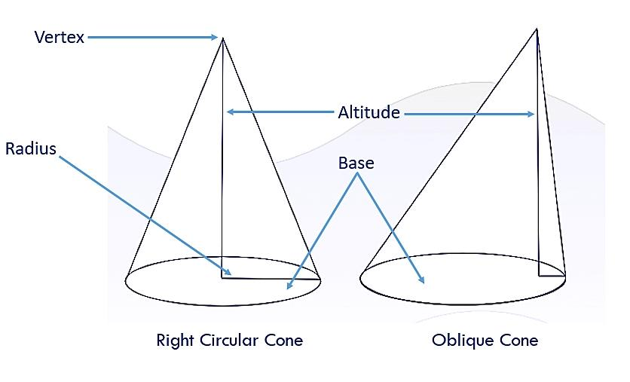
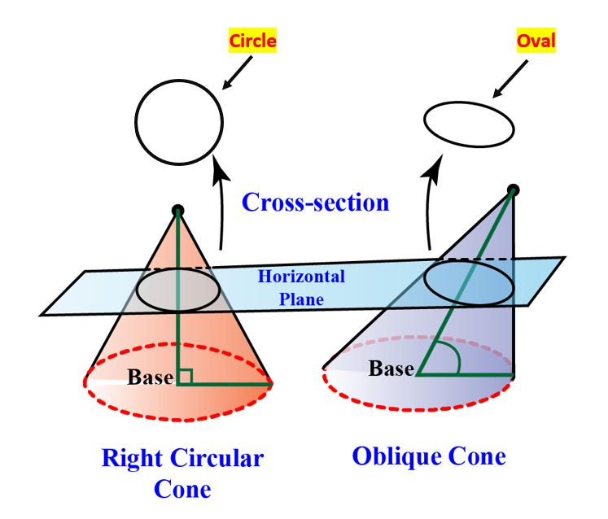
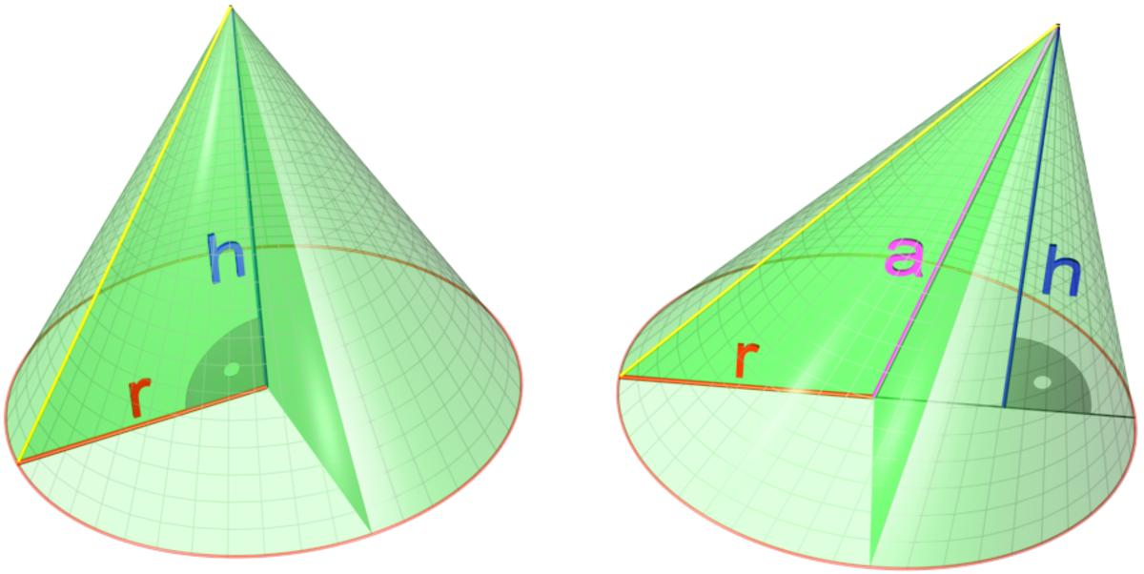
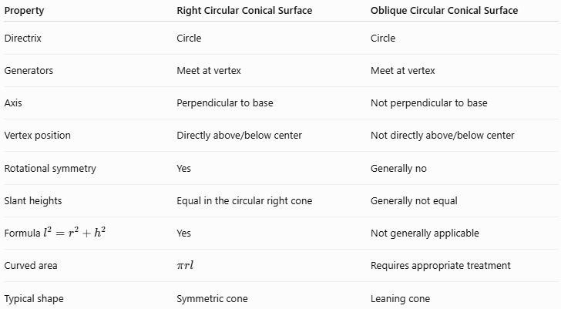
Property | Right Circular Conical Surface | Oblique Circular Conical Surface
Directrix | Circle | Circle
Generators | Meet at vertex | Meet at vertex
Axis | Perpendicular to base | Not perpendicular to base
Vertex position | Directly above/below center | Not directly above/below center
Rotational symmetry | Yes | Generally no
Slant heights | Equal in the circular right cone | Generally not equal
Formula $l^{2}=r^{2}+h^{2}$ | Yes | Not generally applicable
Curved area | $$πrl$$ | Requires appropriate treatment
Typical shape | Symmetric cone | Leaning cone
The defining difference is:
$$\boxed{\text{Right}=\text{axis perpendicular to base}}$$
while
$$\boxed{\text{Oblique}=\text{axis not perpendicular to base}}.$$

Right Circular Conical Surface vs Cylindrical Surface
# Source: AI Source: Provided by: [Data Path: Persons Table -> ID Column: 1, Name_En Column: Motasem Essam] -> From: [ChatGPT] on [7/20/2026]
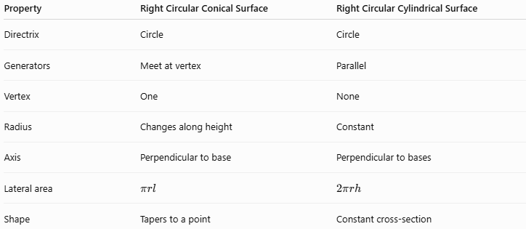
Property | Right Circular Conical Surface | Right Circular Cylindrical Surface
Directrix | Circle | Circle
Generators | Meet at vertex | Parallel
Vertex | One | None
Radius | Changes along height | Constant
Axis | Perpendicular to base | Perpendicular to bases
Lateral area | $$πrl$$ | $$2πrh$$
Shape | Tapers to a point | Constant cross-section
The most important distinction is:
$$\boxed{\text{Cone: generators meet}} \\ \boxed{\text{Cylinder: generators are parallel}}$$

Relationship to the Right Circular Cone
# Source: AI Source: Provided by: [Data Path: Persons Table -> ID Column: 1, Name_En Column: Motasem Essam] -> From: [ChatGPT] on [7/20/2026]
It is important to distinguish the surface from the solid.
Right Circular Conical Surface
Contains only the curved lateral boundary:
$$\boxed{A=πrl}$$
Right Circular Cone
Contains the enclosed three-dimensional solid.
Its volume is
$$\boxed{V=\frac{1}{3}πr^{2}h}.$$
Its total surface area is
$$\boxed{A_{\text{total}}=πrl+πr^{2}}.$$
Therefore:
$$\boxed{\text{Right Circular Conical Surface}⊂\text{Boundary of a Right Circular Cone}}$$
in the geometric-boundary sense.

Real-World Applications
# Source: AI Source: Provided by: [Data Path: Persons Table -> ID Column: 1, Name_En Column: Motasem Essam] -> From: [ChatGPT] on [7/20/2026]
Right circular conical surfaces appear in:
- Traffic cones
- Funnels
- Ice-cream cones
- Conical roofs
- Loudspeakers
- Reflectors
- Searchlights
- Engineering components
- Machine parts
- Optical systems
- Conical tanks
- Architectural structures

Advantages
# Source: AI Source: Provided by: [Data Path: Persons Table -> ID Column: 1, Name_En Column: Motasem Essam] -> From: [ChatGPT] on [7/20/2026]
- Highly symmetric.
- Easy to analyze mathematically.
- Simple relationships between $r$, $h$, and $l$.
- Curved surface area has a simple formula.
- Can be developed into a circular sector.
- Useful in engineering and geometric modeling.

Limitations
# Source: AI Source: Provided by: [Data Path: Persons Table -> ID Column: 1, Name_En Column: Motasem Essam] -> From: [ChatGPT] on [7/20/2026]
- Represents only conical surfaces with a circular directrix and perpendicular axis.
- Cannot represent an oblique cone accurately without modifying the mathematical model.
- The formula $A=πrl$is specific to the appropriate right circular cone case.
- The simple relationship $l^{2}=r^{2}+h^{2}$does not apply to general oblique cones.

Key Points
# Source: AI Source: Provided by: [Data Path: Persons Table -> ID Column: 1, Name_En Column: Motasem Essam] -> From: [ChatGPT] on [7/20/2026]
- A Right Circular Conical Surface is the lateral curved surface of a right circular cone.
- Its directrix is a circle.
- Its generators all meet at one vertex.
- Its axis is perpendicular to the base plane.
- The radius, height, and slant height satisfy
$$\boxed{l^{2}=r^{2}+h^{2}}.$$
- Its curved surface area is
$$\boxed{A=πrl}.$$
- Its lateral surface can be unfolded into a circular sector.
- It has rotational symmetry around its axis.
- It is an open surface when considered without its circular base.
- Adding the circular base creates a closed surface.
- It is a specific type of Circular Conical Surface and therefore a specific type of Conical Surface.

Conclusion
# Source: AI Source: Provided by: [Data Path: Persons Table -> ID Column: 1, Name_En Column: Motasem Essam] -> From: [ChatGPT] on [7/20/2026]
A Right Circular Conical Surface is one of the most important special types of conical surfaces. It is characterized by a circular directrix, generators meeting at a common vertex, and an axis perpendicular to the base plane. Its strong symmetry produces the fundamental relationship
$$l^{2}=r^{2}+h^{2}$$
and the curved surface-area formula
$$A=πrl.$$
For your taxonomy, the clean classification is:
$$\boxed{\text{Conical Surface}→\text{Circular Conical Surface}→\text{Right Circular Conical Surface}}$$

